Static Routing Using Packet Tracer

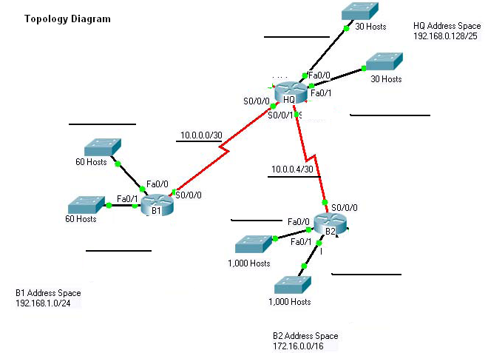

Task 1: Addressing Table
Device | Interface | IP address | Subnet Mask
HQ | Fa 0/0 | 192.168.0.129/27 | 255.255.255.224
HQ | Fa 1/0 | 192.168.0.161/27 | 255.255.255.224
HQ | Serial 2/0 | 10.0.0.1/30 | 255.255.255.252
HQ | Serial 3/0 | 10.0.0.5/30 | 255.255.255.252
B1 | Fa 0/0 | 192.168.1.1/26 | 255.255.255.192
B1 | Fa 1/0 | 192.168.1.65/26 | 255.255.255.192
B1 | Serial 2/0 | 10.0.0.2/30 | 255.255.255.252
B2 | Fa 0/0 | 172.16.0.1/22 | 255.255.252.0
B2 | Fa 1/0 | 172.16.4.1/22 | 255.255.252.0
B2 | Serial 3/0 | 10.0.0.6/30 | 255.255.255.252

Task 2: Subnet Information
Subnet Number | Subnet Address | First Host Address | Last Host Address | Gateway Address
1(30 Hosts) | 192.168.0.128/27  255.255.255.224 | 192.168.0.129/27 | 192.168.0.158/27 | 192.168.0.129/27
2 (30 Hosts) | 192.168.0.160/27  255.255.255.224 | 192.168.0.161/27 | 192.168.0.190/27 | 192.168.0.161/27
3 (60 Hosts) | 192.168.1.0/26  255.255.255.192 | 192.168.1.1/26 | 192.168.1.62/26 | 192.168.1.1/26
4(60 Hosts) | 192.168.1.64/26  255.255.255.192 | 192.168.1.65/26 | 192.168.1.126/26 | 192.168.1.65/26
5(1000 Hosts) | 172.16.0.0/22  255.255.252.0 | 172.16.0.1/22 | 172.16.3.254/22 | 172.16.0.1/22
6(1000 Hosts) | 172.16.4.0/22  255.255.252.0 | 172.16.4.1/22 | 172.16.7.254/22 | 172.16.4.1/22
7 (2 Hosts) | 10.0.0.0/30  255.255.255.252 | 10.0.0.1/30 | 10.0.0.2/30 | N/A
8(2 Hosts) | 10.0.0.4/30  255.255.255.252 | 10.0.0.5/30 | 10.0.0.6/30 | N/A

Task 3: Static Routing Table for Router
Router | Unknown Network Address | Mask Address | Next Hop
HQ | 192.168.1.0/26 | 255.255.255.192 | 10.0.0.2/30
HQ | 192.168.1.64/26 | 255.255.255.192 | 10.0.0.2/30
HQ | 172.16.0.0/22 | 255.255.252.0 | 10.0.0.6/30
HQ | 172.16.4.0/22 | 255.255.252.0 | 10.0.0.6/30
B1 | 192.168.0.128/27 | 255.255.255.224 | 10.0.0.1/30
B1 | 192.168.0.160/27 | 255.255.255.224 | 10.0.0.1/30
B1 | 10.0.0.4/30 | 255.255.255.252 | 10.0.0.1/30
B1 | 172.16.0.0/22 | 255.255.252.0 | 10.0.0.1/30
B1 | 172.16.4.0/22 | 255.255.252.0 | 10.0.0.1/30
B2 | 192.168.0.128/27 | 255.255.255.224 | 10.0.0.5/30
B2 | 192.168.0.160/27 | 255.255.255.224 | 10.0.0.5/30
B2 | 10.0.0.0/30 | 255.255.255.252 | 10.0.0.5/30
B2 | 192.168.1.0/26 | 255.255.255.192 | 10.0.0.5/30
B2 | 192.168.1.64/26 | 255.255.255.192 | 10.0.0.5/30

